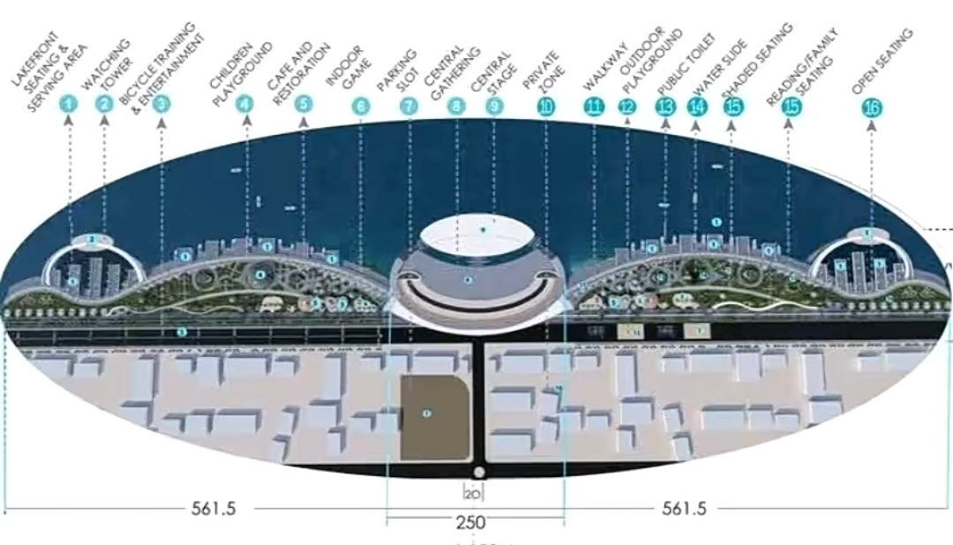
Project plan of the lakeside development around Lake Hawassa aimed at improving tourism and recreational spaces.
Hawassa City Plans Lakeside Development Project to Improve Tourism and Public Spaces.
Dagmawit Dera_April 16, 2026
Hawassa, Ethiopia — The Hawassa City Administration has launched a major lakeside development project aimed at improving tourism, protecting the environment, and creating modern public spaces for residents.
The project, centered around Lake Hawassa, is part of the city’s broader urban development strategy. The Hawassa City Administration says it will transform the lakeside into a more attractive and accessible destination for both locals and visitors.
According to Elias Welde, Design and Contract Administration Team Leader at the Hawassa City Construction Department, the initiative balances development with environmental protection.
“The project will help protect the lake environment while also creating modern recreational spaces for residents and visitors,” he said.

What the Project Includes
- The development plan features:
- Recreational areas for families and visitors
- Walking paths along the lakeside
- Improved public facilities
The Hawassa City Construction Department says these additions are expected to enhance the beauty of the area while making it more user-friendly.
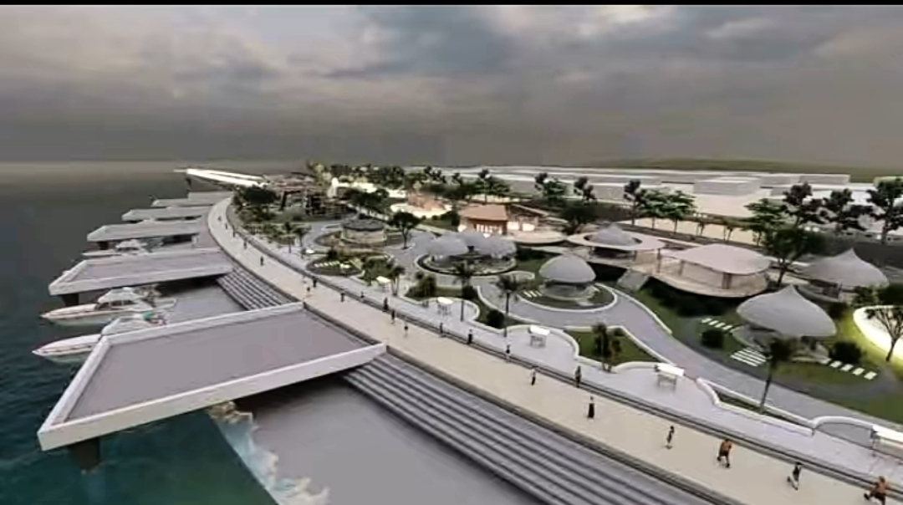
Additional design view showing planned recreational areas and walking paths along Lake Hawassa
Economic and Social Impact
The Hawassa City Administration believes the project will help boost the local economy by attracting more tourists to Hawassa, a city already known for its natural beauty.
Residents have expressed support for the initiative. One local resident, Yayenehtesfaye Mengistu, said the project could significantly improve the lakeside experience.
“It will create better places for families and visitors to spend time,” he said, adding that services should remain affordable for all community members.
Phased Implementation
The Hawassa City Construction Department confirmed that the project will be implemented in phases and is expected to contribute to the long-term development of the city.
- Related Information
For more details about Hawassa City development initiatives, visit:
https://www.facebook.com/61563363361689/posts/122188950644445445/?app=fbl
- Suggested Online Tags
#Hawassa #LakeHawassa #Tourism #UrbanDevelopment #Ethiopia #CityDevelopments

